How Compiler GROMACS
Step #1:
Download GROMACS from GROMACS 5.0 from website:
http://www.gromacs.org/Downloads
install reference guide : http://www.gromacs.org/Documentation/Installation_Instructions
Gromacs Userguide: http://www.gromacs.org/Documentation/Manual
Step #2:
uncompess it by command “ tar –xvf gromacs-<version>.tar.gz
Step #3:
create work directory by command: “mkdir build” and into the work directory – “ cd build” as “cd <gromacs source code install directory>
Step #3:
- build cmake environment of gromacs to use Intel tools.
GROMACS 5.0.x need cmake 2.8+ (see APPENDIX I) and zlib (see APPENDIX II).
Set link library environment:
- export ZLIB_DIR=<lib z install directory>
- export MPICCDIR=<MPI install directory
- Build cmake environment (for GROMACS compile’r parameter, please see APPENDIX III. And you can using a scripts to compiler gromacs – sample scripts see APPENDIX IV ) of gromacs by command as followed:
For CPU version
cmake .. \
-DBUILD_SHARED_LIBS=OFF \
-DGMX_PREFER_STATIC_LIBS=ON \
-DGMX_BUILD_MDRUN_ONLY=ON \
-DGMX_FFT_LIBRARY=mkl \
-DCMAKE_INSTALL_PREFIX=<where the directory to install for gromacs> \
-DGMX_MPI=ON \
-DGMX_GPU=OFF \
-DGMX_XML=OFF \
-DGMX_SOFTWARE_INVSQRT=OFF \
-DGMX_SKIP_DEFAULT_CFLAGS=ON \
-DCMAKE_EXE_LINKER_FLAGS="-L${ZLIB_DIR}/lib64 -mkl=sequential" \
-DCMAKE_CXX_COMPILER=${MPICCDIR}/mpicxx \
-DCMAKE_C_COMPILER=${MPICCDIR}/mpicc \
-DCMAKE_C_FLAGS=" –cc=icc -std=gnu99 -O3 -vec-report1 -mmic -fno-alias -g -DNDEBUG -ip -funroll-all-loops -fimf-domain-exclusion=15 -I${ZLIB_DIR}/include " \
-DCMAKE_CXX_FLAGS="-cxx=icpc -std=gnu++98 -O3 -mmic -vec-report1 -fno-alias -g -DNDEBUG -ip -funroll-all-loops -fimf-domain-exclusion=15 -I${ZLIB_DIR}/include"
“
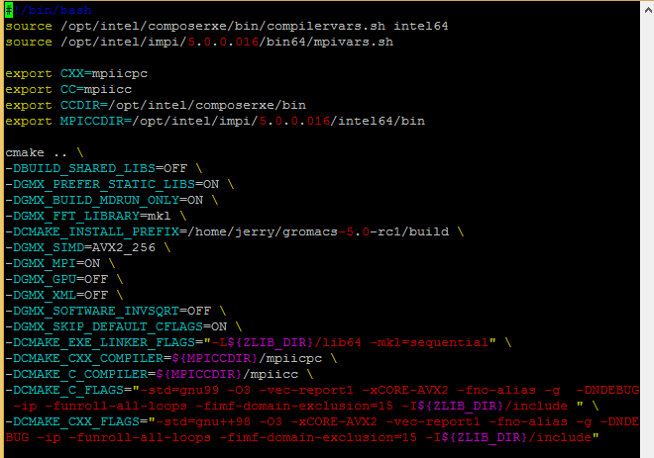
Success to build gromacs compiler environment:
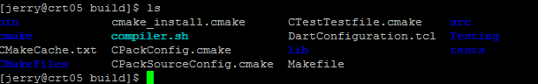
Step #4:
build Intel Tools environment before compiler.
BASH/KSH
source /opt/intel/composerxe/bin/compilervars.sh intel64
source /opt/intel/mkl/bin/mklvars.sh intel64
Step #5:
Compiler gromacs by command “make –j 12”. Please see APPENDIX V, if got some error message.
Compilering:
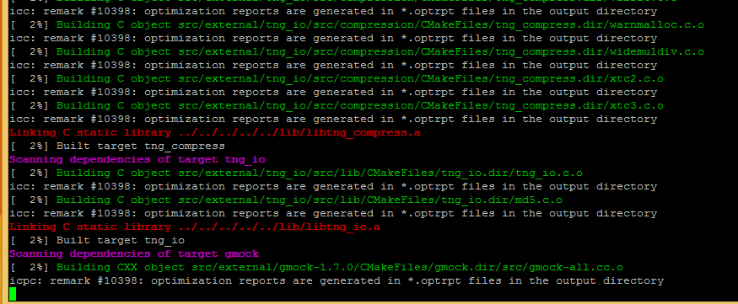

Step #6:
Install gromacs by command “make install”

How to run gromacs
Step #1:
if using Intel tools, build a running environment by command:
BASH/KSH
source /opt/intel/composerxe/bin/compilervars.sh intel64
source /opt/intel/mkl/bin/mklvars.sh intel64
if you native run gromacs on MIC, you can do on MIC as followed:”
source /opt/intel/mkl/bin/mklvars.sh mic
Step #2:
Create grocs input file *.tpr by command as followed:”
Grompp_mpi –f <mdp file> -n <ndx file> -p <top file> -c <data base. PDB file> -o <gromacs input file. *.tpr> [-maxwarn <number>]
“
Step #3:
run gromacs on cluster.
- Run gromacs on Xeon by command:
mpirun –np <total mpi process number> -ppn <mpi process number per node> -machinefile <hostfiles> mdrun_mpi –v –deffnm <input files>

APPENDIX I: CMAKE INSTALL
Step #1:
Download cmake packets from website : http://www.cmake.org/
Reference guide form: http://www.cmake.org/cmake/help/documentation.html
Step #2:
Uncompress cmake packtes by command: tar –xvf cmake-<version>.tar.gz
Step #3:
Prepared to compiler cmake by command “./configure” using compiler which you choice. Set the install direction by arg: -prefix=<cmake install directory>.
- If using GNU compiler, do nothing before “./configure”
- If using Intel compiler, please set “CC, CXX, F77, F90 “ to “icc, icpc. Ifort”
Step #4:
Compiler cmake.
- If no previously version of cmake, please do command “./bootstrap ; make “
- If already install cmake, please do command “ make “
Step #4:
Install cmake on the system by command “make install”, which will install cmake to “/usr/local/share/cmake-<version>”. Replace old cmake command under /usr/local/bin/.

Step #5:
Relogin the server. Than you can using the new cmake.

APPENDIX II: Z LIRARTY INSTALL
Step #1:
Download zlib from website: http://www.zlib.net/
Step #2:
uncompress it by command:” tar xvf zlib-<version>.tgz”
Step #3:
configure it by command: “ ./configure –prefix=<zlib installed directory>” if you used Intel compiler, please do as followed:”
For Xeon:
Export CC=icc
Export CFLAGS=”-O3”
For Xeon Phi:
Export CC=icc
Export CFLAGS=”-O3 –mmic”
“
Step #4:
Compiler zlib by command “make all”.
Step #5:
Install Zlib by command: make install

APPENDIX III: GROMACS CMAKE PARAMETER
Detail see : http://www.gromacs.org/Documentation/
BUILD_SHARED_LIBS: enable | disable internal GROMACS library by ON | OFF.
GMX_PREFER_STATIC_LIBS: Enable | disable external (non- system) libraries by ON | OFF
GMX_BUILD_MDRUN_ONLY: Enable | disable if only build mdrun_mpi executable code by ON | OFF
GMX_FFT_LIBRARY: Choice which FFT library used between fftw,mkl,and fftpack. If used non mkl, please set GMX_BUILD_OWN_FFTW=on and download fftw packets. (fftpack already bundled with GROMACS source code).
CMAKE_INSTALL_PREFIX: where to install GROMACS
GMX_SIMD: support SIMD capability. Include “ SSE2,SSE4.1,AVX_128_FMA,AVX_256,AVX2_256,IBM_QPX,Sparc64_HPC_ACE, None”. You can choice one for your HW architecture.
GMX_MPI: Enable | Disable MPI version of GROMACS by ON | OFF
GMX_GPU: Enable| Disable GPU Native model by ON | OFF.
GMX_SOFTWARE_INVSQRT: Enable | Disable to use SW sqrt by ON | OFF.
GMX_SKIP_DEFAULT_CFLAGS:
CMAKE_EXE_LINKER_FLAGS: Link flags which equal to the name of the C99.
CMAKE_CXX_COMPILER: CXX compiler which equal to the name of C++98.
CMAKE_C_COMPILER: C compiler
CMAKE_C_FLAGS: C compiler flags. Need support C99
CMAKE_CXX_FLAGS: CXX compiler flags. Need support C++98.
CMAKE_INSTALL_PREFIX: to install GROMACS to a non-standard location directory (default: /usr/local/gromacs)
GMX_DOUBLE: Enable | Disable running GROMACS with DP or SP by On | OFF

APPENDIX IV: COMPILER SAMPLING CRIPTS FILES
#!/bin/bash
source /opt/intel/composerxe/bin/compilervars.sh intel64
source /opt/intel/impi/5.0.0.016/bin64/mpivars.sh

export CXX=mpiicpc
export CC=mpiicc
export CCDIR=/opt/intel/composerxe/bin
export MPICCDIR=/opt/intel/impi/5.0.0.016/intel64/bin

cmake .. \
-DBUILD_SHARED_LIBS=OFF \
-DGMX_PREFER_STATIC_LIBS=ON \
-DGMX_BUILD_MDRUN_ONLY=ON \
-DGMX_FFT_LIBRARY=mkl \
-DCMAKE_INSTALL_PREFIX=/home/jerry/gromacs-5.0-rc1/build \
-DGMX_SIMD=AVX2_256 \
-DGMX_MPI=ON \
-DGMX_GPU=OFF \
-DGMX_XML=OFF \
-DGMX_SOFTWARE_INVSQRT=OFF \
-DGMX_SKIP_DEFAULT_CFLAGS=ON \
-DCMAKE_EXE_LINKER_FLAGS="-L${ZLIB_DIR}/lib64 -mkl=sequential" \
-DCMAKE_CXX_COMPILER=${MPICCDIR}/mpiicpc \
-DCMAKE_C_COMPILER=${MPICCDIR}/mpiicc \
-DCMAKE_C_FLAGS="-std=gnu99 -O3 -vec-report1 -xCORE-AVX2 -fno-alias -g -DNDEBUG -ip -funroll-all-loops -fimf-domain-exclusion=15 -I${ZLIB_DIR}/include " \
-DCMAKE_CXX_FLAGS="-std=gnu++98 -O3 -xCORE-AVX2 -vec-report1 -fno-alias -g -DNDEBUG -ip -funroll-all-loops -fimf-domain-exclusion=15 -I${ZLIB_DIR}/include"

APPENDIX V: GROMACS COMPILER ERROR MESSAGE
- vec.h(531): error: identifier "rsqrtf" is undefined cosval = ip*gmx_invsqrt(ipab); /* 7 */
Solution A:
Modified file: build/src/config.h
Line#272:
#define HAVE_RSQRT /* #define HAVE_RSQRT */
Line#275:
#define HAVE_RSQRTF /* #define HAVE_RSQRTF */
Solution B:
Before create gromacs makefile file, please do as followed:
Set BUILD_SHARED_LIBS=OFF to BUILD_SHARED_LIBS=ON
Set GMX_PREFER_STATIC_LIBS=ON to GMX_PREFER_STATIC_LIBS=OFF
- smalloc.c:359: undefined reference to `_aligned_free'
Solution:
Modified file build/src/config.h
Line#236: #define HAVE__ALIGNED_MALLOC /* #define HAVE__ALIGNED_MALLOC */
- utilities.c:731: undefined reference to `_finite'
Solution:
Modified file: <GROMACS Source Code directory>/src/gromacs/math/utilities.c
Line#731: returnval = _finite(x); /* returnval = _finite(x); */

